
Assessment Cover Sheet

Due Date
13 April 2025
Course Code
EN8911

Assessment Title
Progress Report

Course Title
Engineering Research Project

Internal Moderator’s Name
Prof. Dimitrios Mathioulakis

External Examiner’s Name
Dr. Arun Arjunan

Not must-pass
Individual
Uncontrolled
Assessment Type

Instructions:
- This cover sheet must be completed (section in red below) and attached to your assessment before submission in hard copy/soft copy.
- The time allowed for this assessment is till 13 April 2025, Time 23:59.
- This assessment carries 15 % marks and assessing CILO 1, 2 and 4.
- The use of generative AI tools is strictly prohibited.
- References consulted (if any) must be properly acknowledged and cited.
- The assessment has a total of 3 pages.

Programme Title
Learner ID

Date Submitted

Learner Name

Programme Code
Lecturer’s Name

By submitting this assessment for marking, I affirm that this assessment is my own work.
Learner Signature

Do not write beyond this line. For assessor use only.
Assessor’s Name

Marking Date

Maks Obtained

Comments:

Description

1.Problems and Driving Questions

Inspecting pipelines in the oil and gas sector is difficult due to the inflexibility and high cost of traditional rigid robots. These robots struggle to navigate complex and small-diameter pipelines, hindering effective defect detection and increasing the risk of failures. This project aims to overcome these limitations by investigating bio-inspired soft robotics as a more adaptable and cost-effective inspection solution. Make it like human writing.
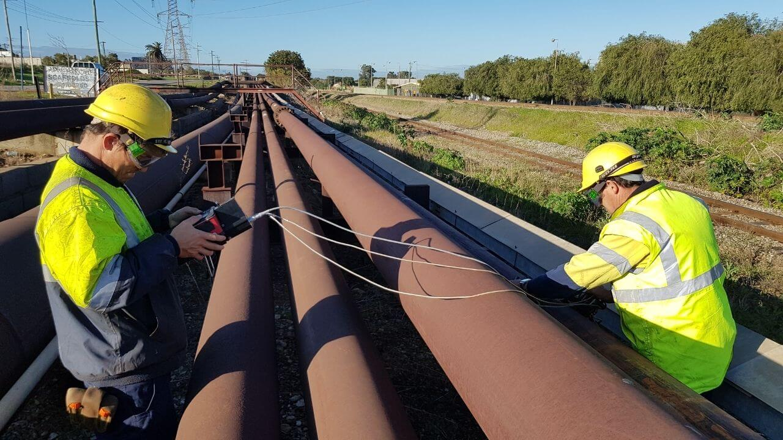
Figure 1 Pipeline Inspecting.

The key questions driving this project are:
- What design features allow for expansion through air pressure, and what is the maximum expansion capacity within the pipeline?
- How does the robot navigate vertical or inclined pipelines, and what modifications are required for these situations?
- Which elastomeric materials achieve the best combination of flexibility, durability, and ease of fabrication for the soft actuators?
- How does 3D-printed mold casting compare to other fabrication methods, such as direct 3D printing of soft materials, in terms of cost and performance?
- In what ways can real-time feedback from cameras and other sensors (such as pressure) enhance navigation and defect detection?

2. Research Methodology

Significant progress has been made in the design process for both the radial and linear components, informed by the casting experience and the design of the internal balloon. Additionally, the ANSYS program was utilized to assess expansion and pressure characteristics.
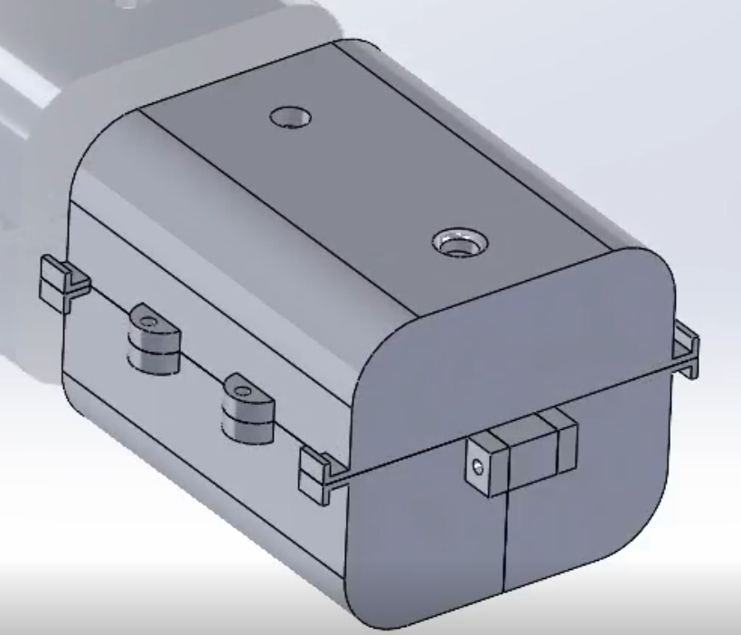
Figure 2 First design of radial.

First design of radial part: The first design for the radial component emerged after several creative attempts. It was crafted to achieve a 20% expansion, enabling it to adapt effectively within the pipeline during both expansion and contraction.

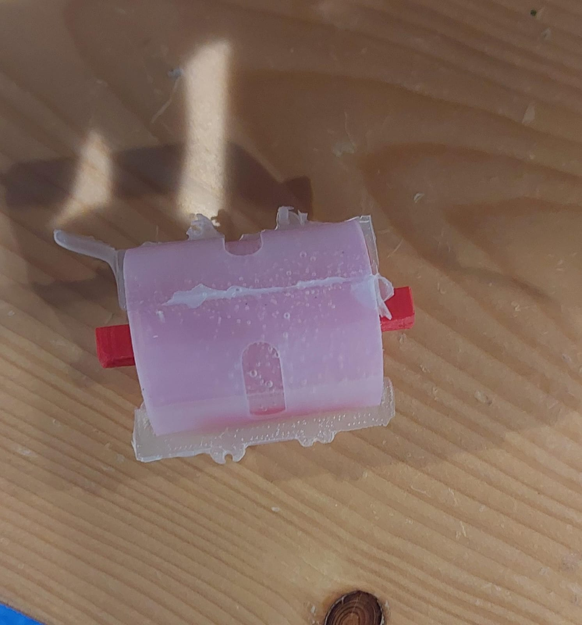
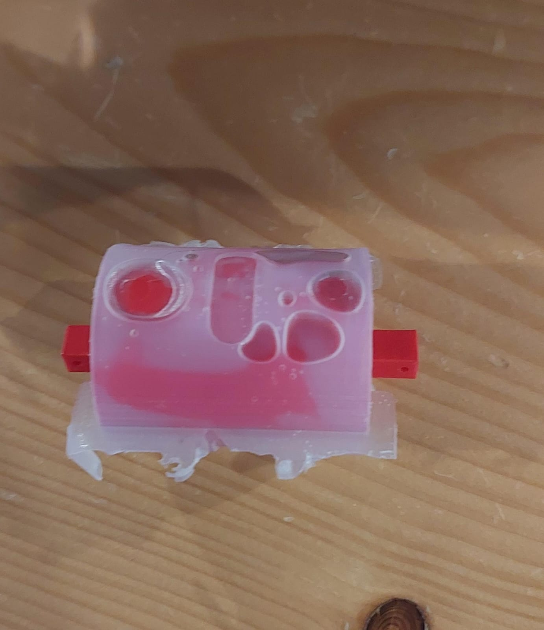
Figure 3 Material after casting process.
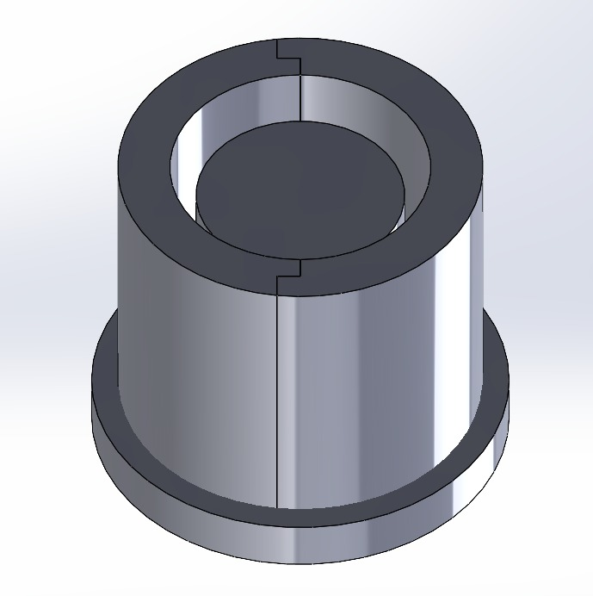
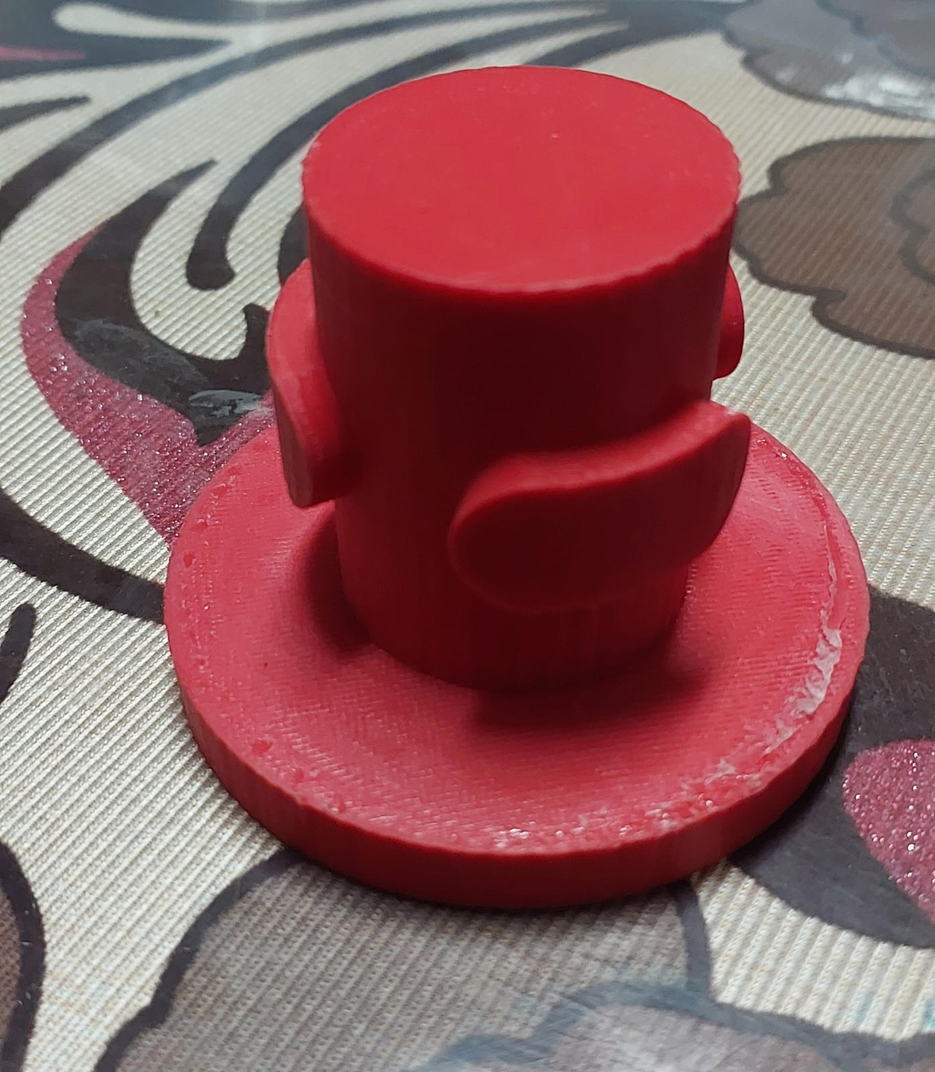
As observed in the Figure 3, bubbles formed during the casting process, leading to cracks in the design. Additionally, a weak thickness was noted, highlighting the need for design improvements. To address the bubble issue, we agreed to implement a vacuum system to mitigate problems during the casting process and strengthen the problematic areas.
Figure 4 Improve the radial part.

Radial part: As previously mentioned, the design required revisions, so we created an alternative that incorporates radioactive elements. This new design is compatible with the required expansion specifications and addresses other critical considerations.
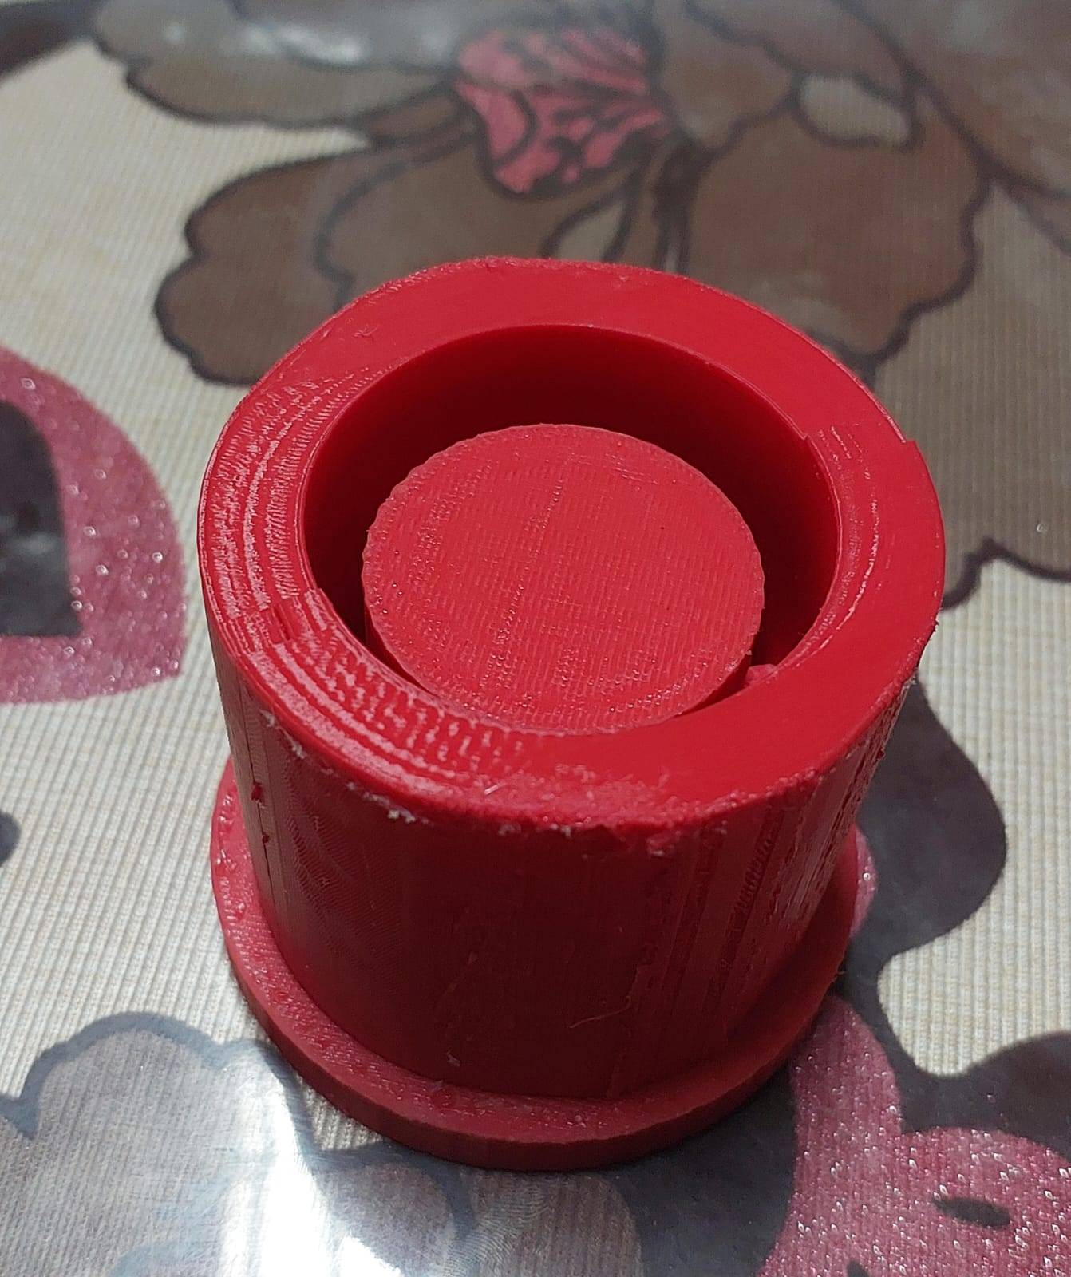
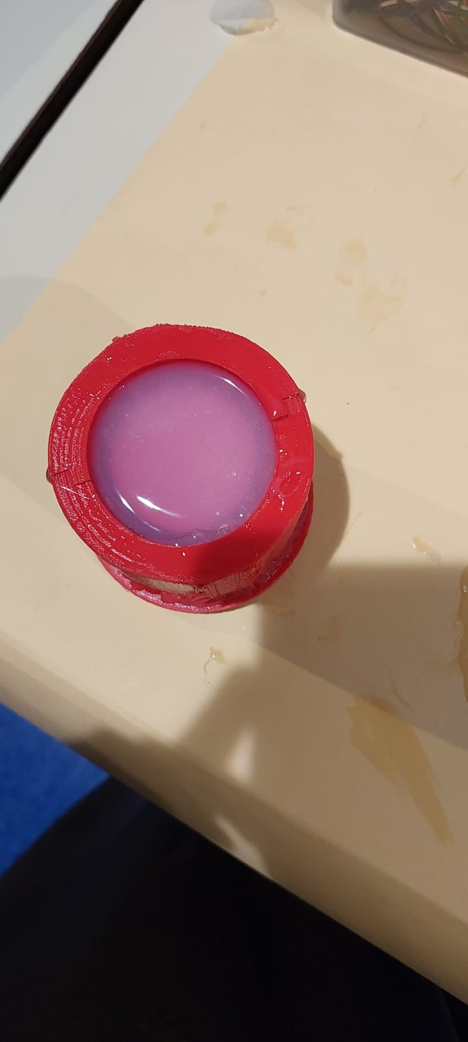
Figure 5 casting process.

After extracting the material in the lab, we developed an acceptable design. However, to finalize our choice, we need to conduct simulations using analysis software. As a preliminary design, this iteration addresses all the issues found in the previous version, making it easier to manage during the casting process.

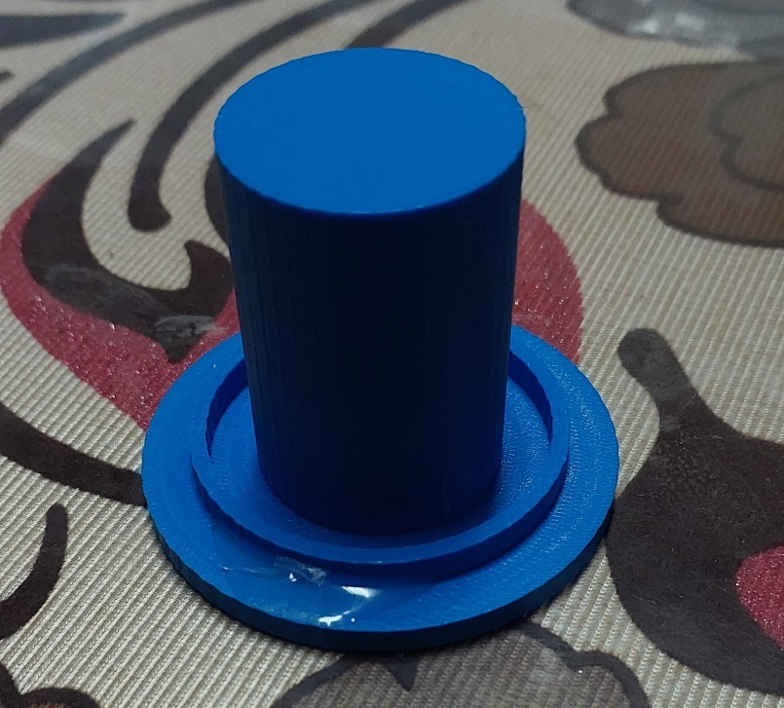

Figure 6 Balloon design.

Balloon: The balloon will be integrated within the radial design, allowing it to expand and effectively support the pipeline. This configuration is essential for maintaining stability and accommodating the necessary expansion.
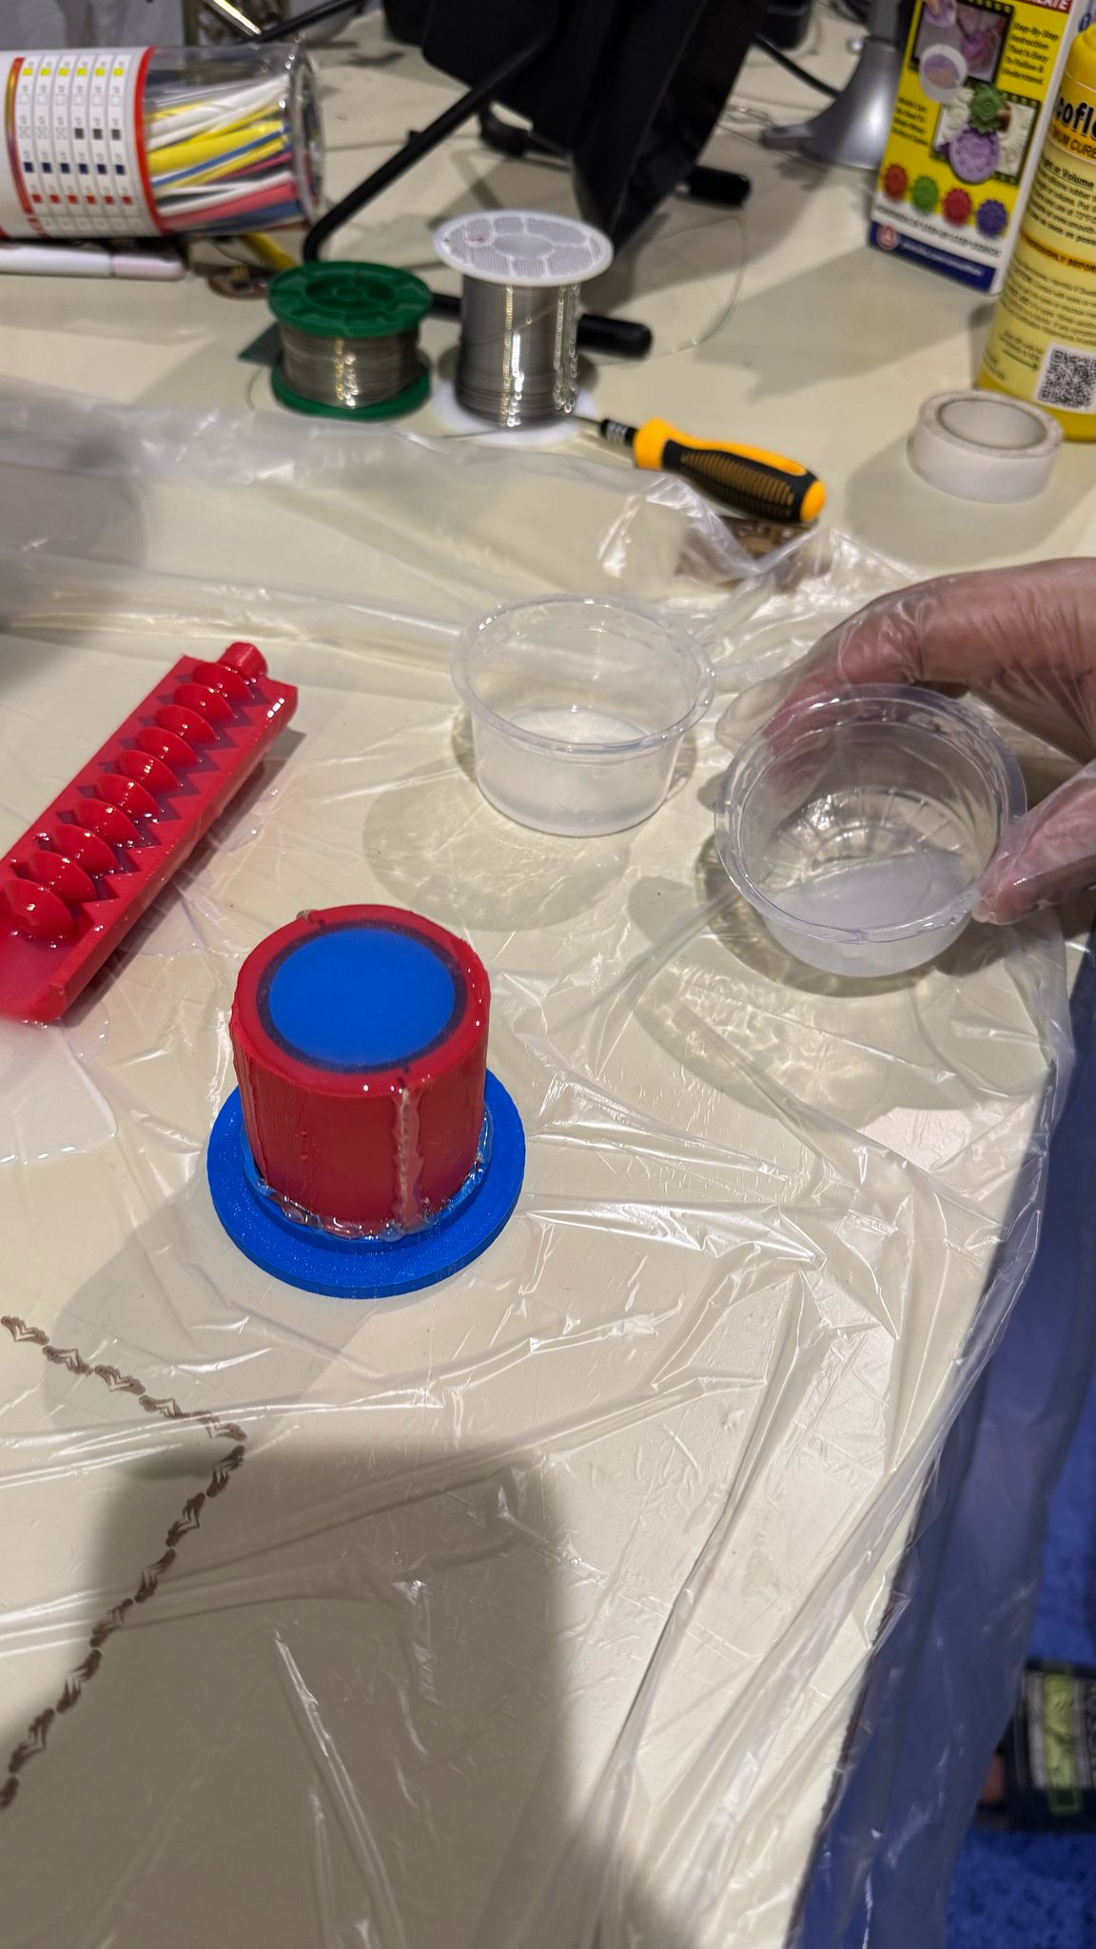
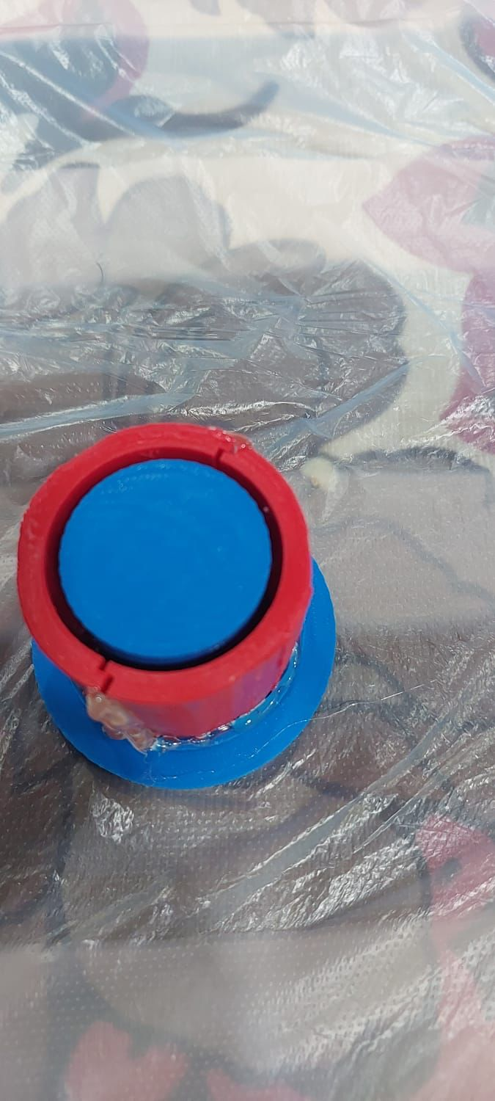
Figure 7 casting process for balloon.

Ballon: The extracted balloon material demonstrated excellent flexibility in expansion, which is crucial for the required range when pumping air into the component. This characteristic ensures that the material can effectively accommodate the necessary expansion.

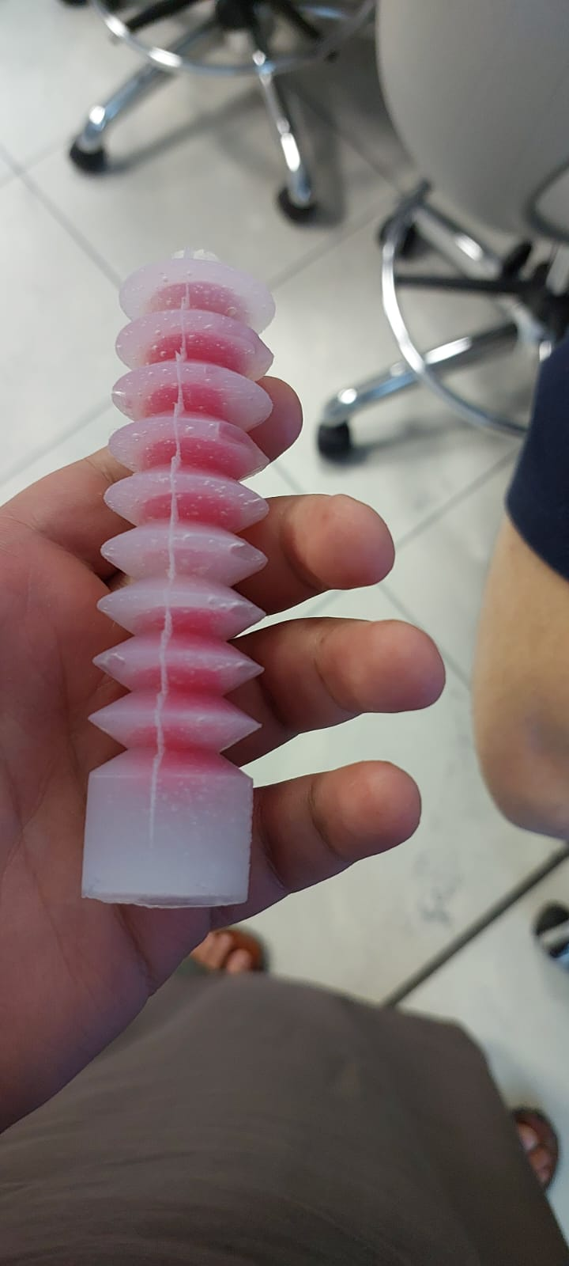
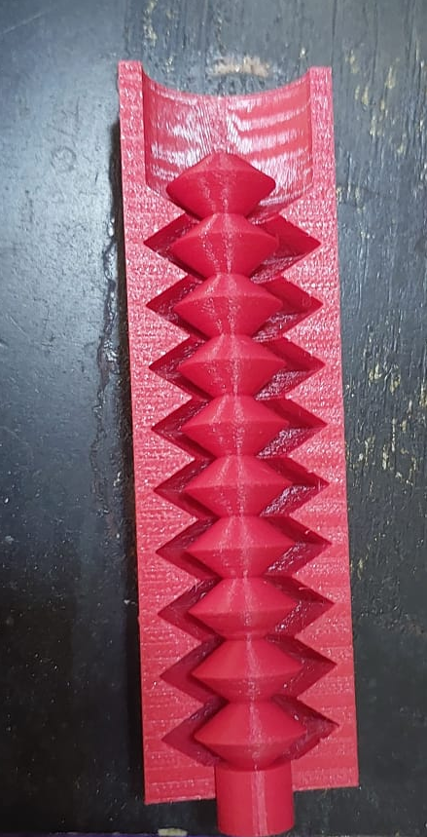
Figure 8. liner part after the casting process.
Figure 9 liner part.

As shown in the Figure 8, the initial radial linear design was promising, but it requires adjustments to reduce the force on the middle piece. This will facilitate easier extraction after the casting process, eliminating the need to cut and refusion with the same material (silicon) to remove the middle piece.

4. Measurable Outcomes
. Design and Expansion Capacity
- Developed a radial component design capable of 20% expansion to fit within pipelines.
- Identified and addressed bubble formation and weak thickness during casting by proposing a vacuum system for future iterations.
- Created an improved radial design incorporating radioactive elements to meet expansion specifications and facilitate casting.
2. Material Performance and Fabrication
- Tested elastomeric materials (silicone) for flexibility and durability, noting excellent expansion properties in balloon prototypes.
- Resolved casting issues (cracks) through iterative design improvements and process adjustments.
3. Navigation and Structural Adaptations
- Designed a balloon-integrated radial system to stabilize and support pipeline expansion during operation.
- Modified the linear component to reduce force on the middle piece, simplifying post-casting extraction.
- Initiated ANSYS simulations to evaluate pressure tolerance and expansion dynamics for the liner part and radial pipeline navigation.
4. Sensor Integration and Feedback
- Proposed real-time feedback mechanisms using cameras and pressure sensors to enhance defect detection and navigation accuracy.

5. Tasks in Detail: Partial Results and Conclusions

Task 1: Radial Soft Actuator Development
Objective: Develop a radial soft actuator capable of 20% expansion to fit varying pipeline diameters.
Partial Results:
- The initial prototype experienced bubble-induced cracks and weak structural integrity.
- The revised design was stronger and more cohesive, with no cracks but minor bubble formation.
Conclusion:
- Vacuum casting significantly reduces defects, but further ANSYS simulations are needed to validate stress distribution.
Task 2: Linear Actuator Optimization
Objective: Optimize the linear actuator for smooth navigation and force distribution.
Partial Results:
- The initial centerpiece design was too strong, complicating extraction post-casting.
- Modified geometry to reduce friction points, allowing for easier removal without cutting.
Conclusion:
- Adjustments improved manufacturability; however, real-world pipeline friction tests are required for further validation.
Task 3: Optimal Elastomer Identification
Objective: Identify optimal elastomers for flexibility, durability, and ease of fabrication.
Partial Results:
- Silicone-based materials demonstrated high elasticity.
- 3D-printed molds proved to be more cost-effective than direct 3D printing of soft materials.
Conclusion:
- Silicone remains the primary candidate; vacuum degassing is critical for achieving defect-free casting.

6. The Most Important Things That I Have Learnt
Key Lessons Learned
- Design Iteration is Critical: Initial prototypes often fail due to unforeseen issues, such as bubble-induced cracks and weak thickness.
- Lesson: Rapid prototyping and iterative testing are essential for refining designs before final fabrication.
- Material Selection Impacts Performance: Silicone offers excellent flexibility but requires reinforcement to prevent tearing.
- Lesson: Material properties must align with operational demands, particularly regarding pressure.
- Fabrication Processes Introduce Defects: Casting without vacuum degassing led to bubbles and cracks.
- Lesson: Process controls, such as vacuum degassing, are necessary to ensure material integrity.
- Simulation Guides Improvement: ANSYS simulations revealed stress concentrations in early designs.
- Lesson: Computational modeling saves time and resources by predicting failures before physical testing.

7. Reflection on Time Allocation and Alternative Approaches

1-Design Phase: A significant portion of our time was spent refining the radial and linear components to ensure functionality and adaptability.
Future Recommendation: Allocate additional time for early prototyping. Utilizing rapid prototyping methods could accelerate the iteration process and lead to quicker feedback.
2-Testing and Evaluation: Considerable time was devoted to testing elastomeric materials and assessing casting methods.
Retrospective Insight: Parallel testing of multiple materials could have provided comparative insights earlier. Establishing a more structured testing schedule would ensure that evaluations are consistent and efficient.

Alternative Approaches
1-Agile Methodology: Adopting an agile approach could foster flexibility in our workflow. Regular sprints with defined goals would allow for continuous assessment and adaptation, keeping us aligned with project objectives.
2-Collaboration with Experts: Engaging with experts in soft robotics and materials science earlier could provide valuable insights and reduce trial-and-error phases. Establishing partnerships with universities or industry leaders might enhance innovation and efficiency.
3-Advanced Simulation Tools: Utilizing advanced simulation tools earlier in the design process could streamline efforts in evaluating pressure dynamics and material behaviors, potentially reducing the need for extensive physical prototyping.

8. Most Enjoyable and Least Enjoyable

Most Enjoyable
1-Creative Problem-Solving: Designing bio-inspired soft actuators and iterating on prototypes was intellectually stimulating. Witnessing rough sketches evolving into functional components was deeply rewarding.

2-Hands-On Fabrication: Working in the lab—casting silicone, testing materials, and assembling prototypes—provided a tangible sense of progress. The moment the balloon actuator first expanded successfully was a highlight.

3-Interdisciplinary Collaboration: Brainstorming with peers from robotics, materials science, and mechanical engineering brought fresh perspectives and innovative solutions.

4-Real-World Relevance: Knowing that the project could improve pipeline safety in the oil and gas industry added motivation and purpose.

Least Enjoyable
1-Repetitive Troubleshooting: Addressing recurring defects, especially when solutions weren’t immediately obvious.
2-Time-Consuming Simulations: Running ANSYS analyses was critical but tedious, with long processing times delaying design iterations.
3-Documentation Overload: Maintaining detailed logs of every test and iteration was necessary but often disrupted creative momentum.

9. Employability Skills Reflection

(a) Development of Employability Skills During the Project
1-Teamwork
- Collaborated with Fadel on design iterations, coordinated lab work schedules, and shared responsibilities for testing and documentation.
- Learned to integrate diverse perspectives into technical solutions.
2-Communication
- Engaged with specialists in the inspection department to gather insights and opinions.
- Explained complex concepts to non-technical team members, enhancing both written and verbal communication clarity.
3-Technology
- Gained hands-on experience with ANSYS simulations, 3D printing for mold fabrication, and sensor integration.
- Became proficient in using specialized software for design and analysis.
4-Self-Management
- Managed project timelines independently, adapting to unexpected delays (e.g., material defects).
- Balanced multiple tasks (design, testing, documentation) simultaneously.
5-Problem Solving
- Identified and resolved technical challenges (e.g., bubble formation in casting) through systematic analysis and creative redesigns.
6-Initiative and Enterprise
- Proposed improvements, such as using a vacuum in the casting system.
- Researched alternative materials and methods beyond the initial project scope.
7-Planning and Organizing
- Structured the project into clear phases (design → prototyping → testing).
- Allocated resources efficiently and prioritized tasks to meet deadlines.
8-Learning
- Quickly mastered new concepts in soft robotics, material science, and simulation tools.
- Demonstrated the ability to acquire and apply knowledge independently.

(b) Most Important Skills for Future Profession

1-Problem Solving: Essential for engineering positions, problem-solving skills are crucial when facing unexpected challenges. The ability to identify issues and devise solutions is universally beneficial.
2-Technology:Expertise in simulation tools like ANSYS and fabrication methods such as 3D printing is highly applicable across various engineering disciplines.
3-Communication: Strong documentation and presentation abilities facilitate effective collaboration within technical teams and with stakeholders.
4-Planning and Organizing: Effective project management through structured planning ensures optimal use of time and resources, which is vital in industry roles.

(c) Industry Knowledge Gaps and Improvements

1. Exposure to Industry Standards
Gap: Limited understanding of real-world constraints (e.g., cost, scalability) in pipeline inspection.
Improvement: Shadow professionals or attend industry workshops to observe operational workflows.
2. Business Acumen
Gap: Lack of knowledge about project bidding, budgeting, or ROI analysis.
Improvement: Enroll in short courses on engineering economics or participate in case studies.
3. Improvement Plan
Short-Term: Review key industry standards (API, ASME, ISO) and compare project parameters against them.
Long-Term: Attend webinars or certification courses (e.g., NACE coating inspection) to formalize knowledge.
Practical Step: Interview professionals in pipeline inspection to understand how standards are applied in daily operations.
4. Cross-Disciplinary Collaboration
Gap: Limited interaction with non-engineering teams (business, operations).
Improvement: Pursue projects or internships that require collaboration across departments.

Recommendations:

Enhance Industry Exposure
- Actively seek opportunities to shadow professionals in the pipeline inspection field.
- Participate in industry workshops to gain practical insights into real-world constraints, such as cost and scalability.
Develop Business Acumen
- Enroll in short courses focused on engineering economics, project bidding, and ROI analysis.
- Engage in case studies to deepen understanding of the financial aspects related to engineering projects.
Strengthen Knowledge of Industry Standards
- Regularly review key industry standards (API, ASME, ISO) and assess how current project parameters align with these standards.
- Attend webinars and certification courses, such as NACE coating inspection, to formalize this knowledge.
Foster Cross-Disciplinary Collaboration
- Pursue internships or projects that require collaboration with non-engineering teams, such as business and operations.
- Enhance communication skills and gain a broader perspective on project impacts.
Implement Agile Methodologies
- Adopt agile practices in project management to facilitate flexibility and responsiveness.
- Use regular sprints with defined goals for continuous assessment and adaptation of project objectives.
Invest in Advanced Simulation Tools
- Explore and utilize advanced simulation tools early in the design process.
- Streamline evaluations of pressure dynamics and material behaviors, reducing the need for extensive physical prototyping.
Encourage Continuous Learning
- Establish a structured approach to learning new concepts in soft robotics, material science, and simulation tools.
- Schedule regular training sessions or workshops to keep skills current.
Emphasize Iterative Design and Testing
- Continue to focus on rapid prototyping and iterative testing to refine designs.
- Allocate time for early prototyping to gather feedback and make informed adjustments efficiently.

